Cumann Naomh Pádraig An Eaglais

AGM 30th November at 8pm

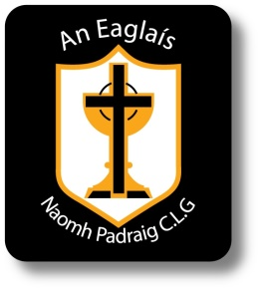
Please find nomination forms and motions papers attached for AGM which will be held on Wednesday 30th November in clubrooms at 8pm. Please note that nominations and motions will only be considered from paid up members.

Ainmniúcháin (Nominations)

Cathaoirleach
(Chairperson)
Leas Cathaoirleach  (Vice Chairperson) | 1.  2.
Rúnaí
(Secretary)
Leas Rúnaí
(Assistant Secretary)
Cisteoir
(Treasurer)
Leas Cisteoir
(Assistant Treasurer)
Cláraitheoir
(Registrar)
Oifigeach na nÓg
(Youth Officer)
Oifigeach Cultur & Teanga
(Culture & Language Officer)
Oifigeach Caidreamh Poiblí
(PRO & IT)
Coiste
(Committee)

Your Name
Please note that permission must be sought from the nominee prior to their nomination

Return completed forms to Rúnaí Paul Donaghy by Friday 25th of November
Na Rúin agus na Moltái
(Motions and Recommendations)

Motions:

Recommendations:

Your Name

Return completed forms to Rúnaí Paul Donaghy by Friday 25th of November

