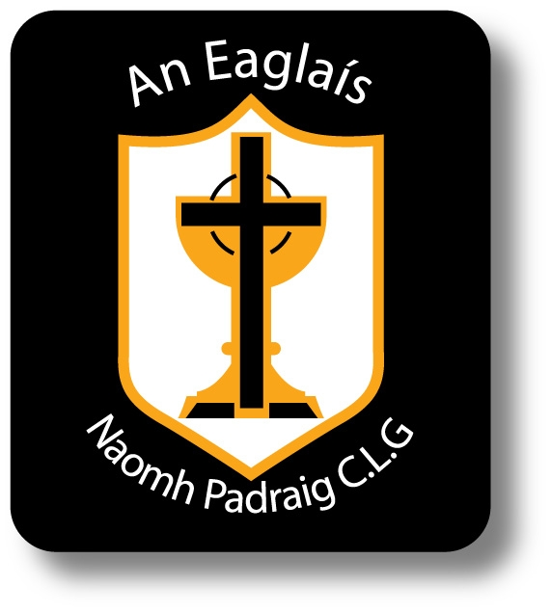
Cumann Naomh Pádraig An Eaglais

AINMNIÚCHAIN
(Nominations)

Cathaoirleach: ____________________________________ e-mail: ____________________________
(Chairman)

Leas-Cathaoirleach: 1._____________________________ e-mail: ____________________________
(Vice-Chairman)
2._____________________________ e-mail: ____________________________

Rúnaí: ____________________________________ e-mail: ____________________________
(Secretary)

Leas-Rúnaí: ____________________________________ e-mail: ____________________________
(Asst. Secretary)

Cisteoir: ____________________________________ e-mail: ____________________________
(Treasurer)

Leas-Cisteoir: ____________________________________ e-mail: ____________________________
(Asst. Treasurer)

Cláraitheoir: ____________________________________ e-mail: ____________________________
(Registrar)

Oifigeach na mÓg: ________________________________ e-mail: ____________________________
(Youth Officer)

Oifigeach Teanga & Cultur: ________________________ e-mail: ____________________________
(Language & Culture Officer)

Oifigeach Caidreamh Poiblí: _______________________ e-mail: ____________________________
(PRO)

I wish to be part of the club committee for the incoming year _________

Ainm: _______________________________ e-mail: ____________________________

Siníthe: ___________________________ Dáta: _________________

NA RÚIN
(Motions)

Siníthe: ___________________________ Dáta: _________________

